1. ***Summary query to show the sales, and costs associated with each customer or customer type on an annual, quarterly, monthly or weekly basis***

***.***

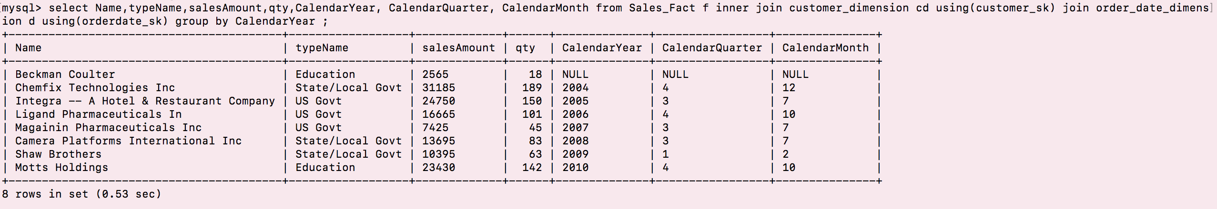

1. **Summary query to show the sales, and costs associate at the product level/ product type/ business unit**

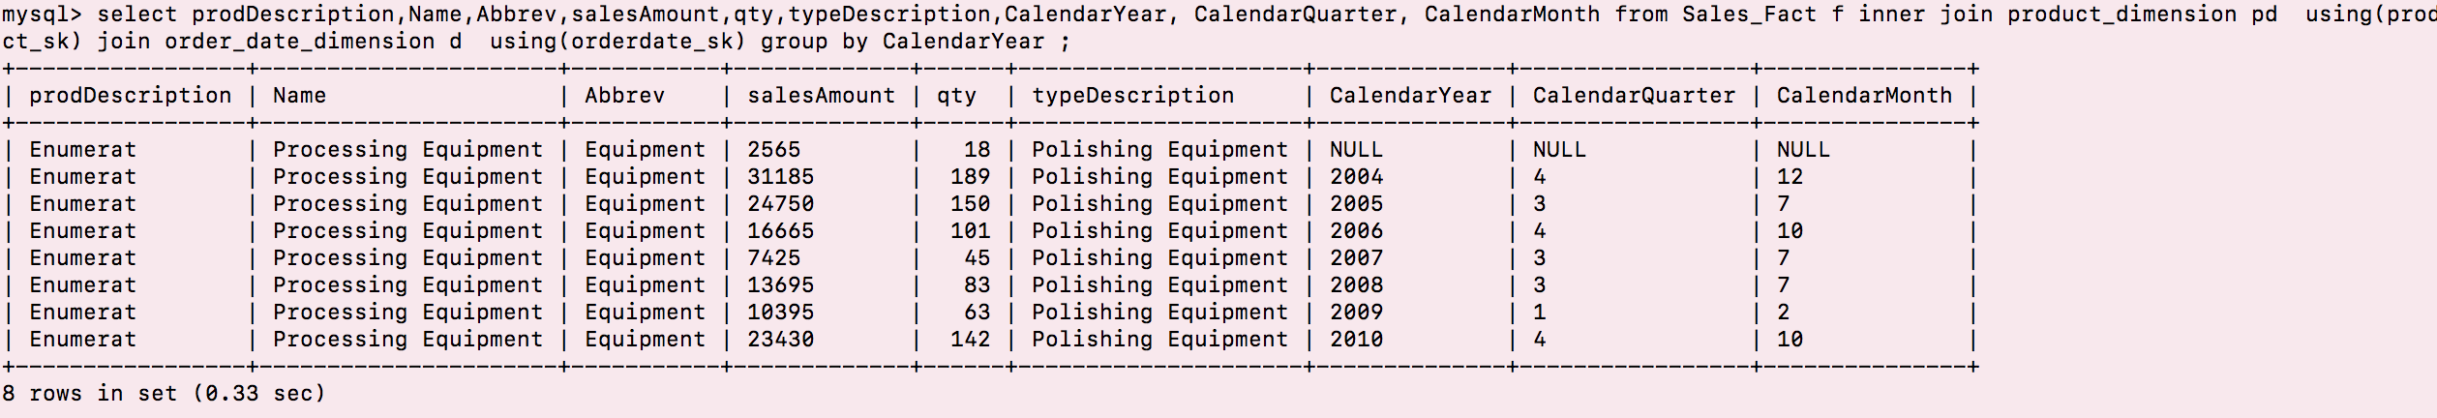

1. ***Query to find the average number of products supplied by each supplier***

